Copyright for test papers and marking guides remains with *West Australian Test Papers.*

Test papers may only be reproduced within the purchasing school according to the advertised Conditions of Sale.

Test papers should be withdrawn after use and stored securely in the school until Thursday 15th October 2020.



**SEMESTER TWO**

**MATHEMATICS**

**METHODS**

**UNITS 3 & 4**

**2020**

**SOLUTIONS**

**Calculator−free Solutions**

1. (a)

|  |  |  |  |  |
| --- | --- | --- | --- | --- |
| *a* | −1 | 0 | 1 | 2 |
| P(*A* = *a*) | 0.2 | 0.3 | 0.4 | 0.1 |

✓✓

(b)  ✓

= −0.2 + 0.4 + 0.2 = 0.4 or $400 ✓

(c)  ✓

= 0.2 + 0.4 + 0.4 − 0.16 ✓

= 0.84 ✓ [7]

2. (a)

|  |  |  |
| --- | --- | --- |
| *m* | 0 | 1 |
| P(*M* = *m*) |  |  |

✓✓

(b) It has two possibilities, independent events and is a DRV ✓

(c) 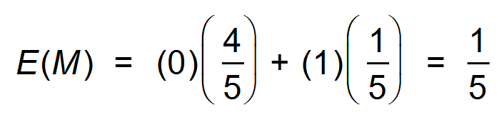 ✓

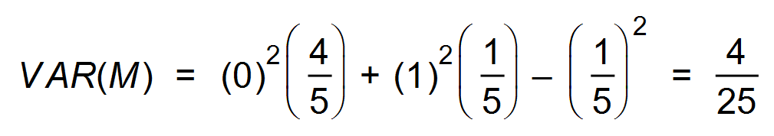

∴ SD = 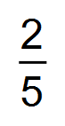 ✓

(d) X ~ B(8,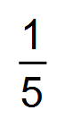) ✓

(e) 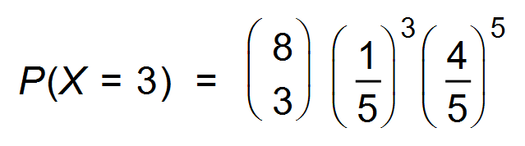 ✓ [7]



3. (a) 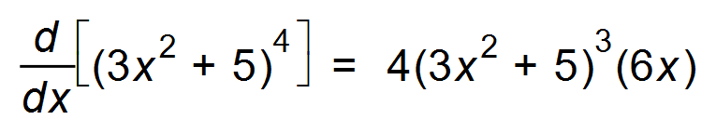 ✓✓

(b) 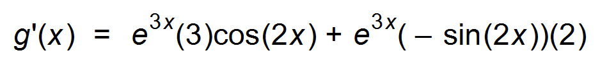 ✓

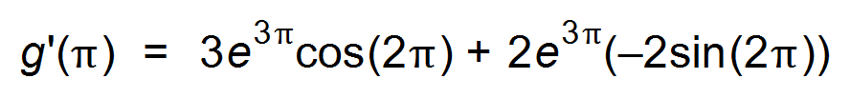 ✓

∴ 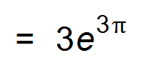 ✓

(c) (i) 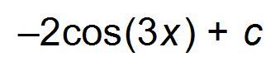 ✓✓

(ii) ✓

= ln (7) − ln(1) = ln 7 ✓

(d) 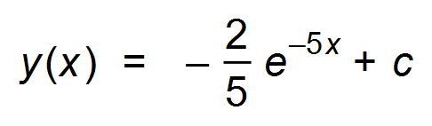 ✓

Since 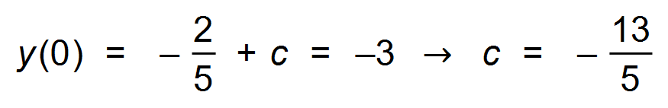

∴ 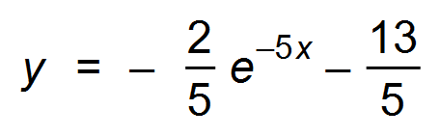 ✓ [11]

4. (a) 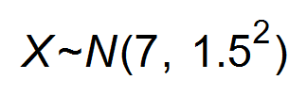

∴ 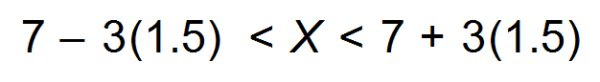 ✓

∴ 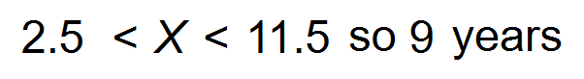 ✓

(b) 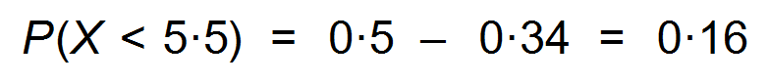 ✓

∴ 16% ✓

(c)  ✓✓ [6]

5. 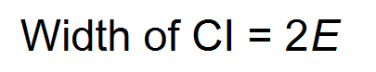

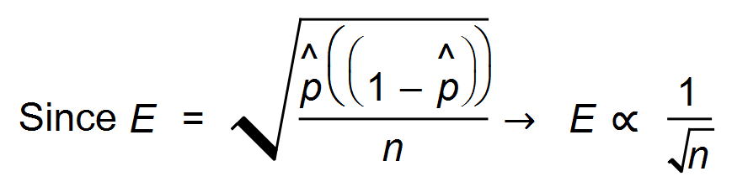 ✓

∴ 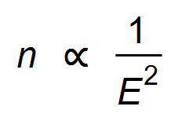 ✓

∴ 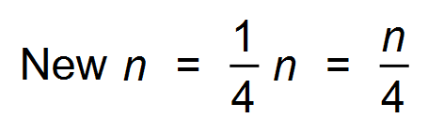 ✓ [3]

6. (a) (i) 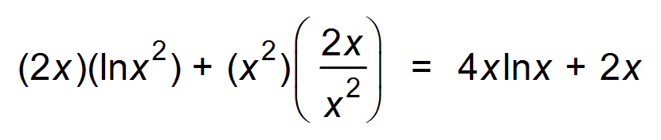 ✓✓

(ii) 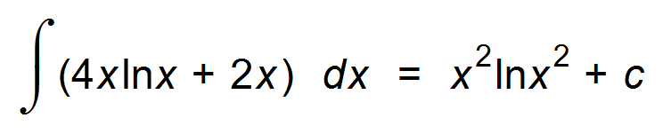 ✓

∴ 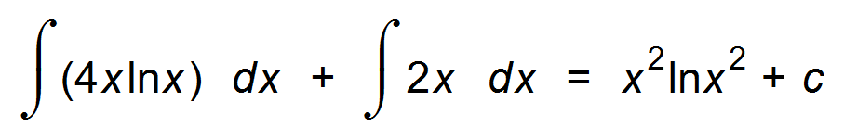 ✓

∴ 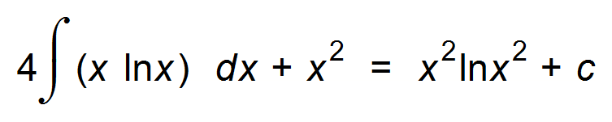 ✓

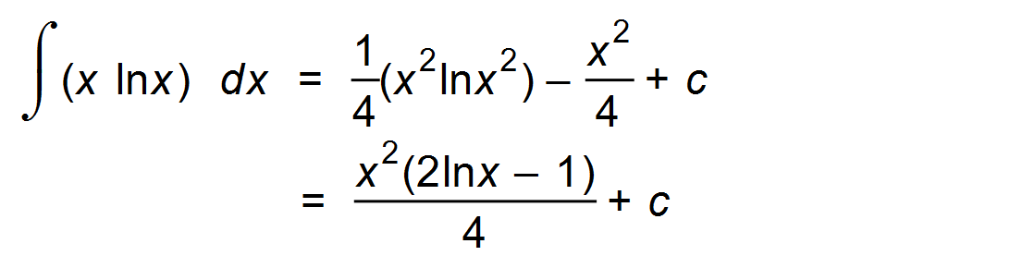 ✓

(b) Area = 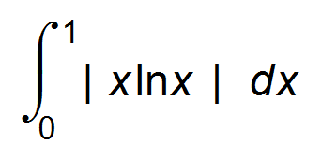 ✓

= − ✓

= −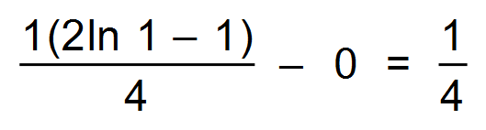 ✓✓ [10]

7. 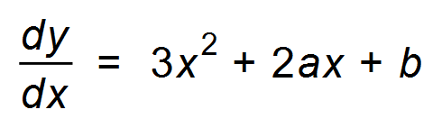 ✓

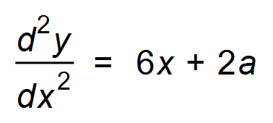 ✓

Since HPOI 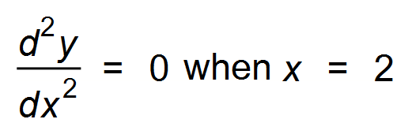 ✓

∴ 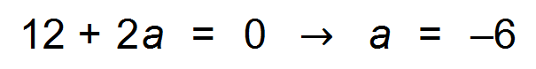 ✓

And 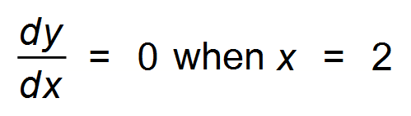

∴ 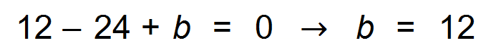 ✓

(2, 8)  ✓ [6]

**Calculator−Assumed Solutions**

8. (a) 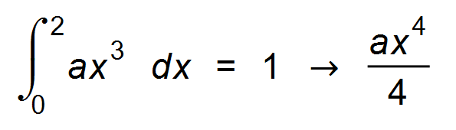] = 1 ✓

∴ 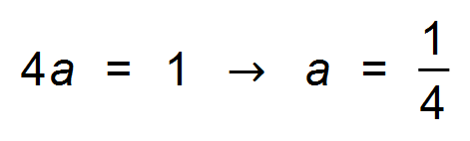 ✓

(b) 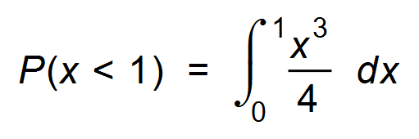  ✓

= 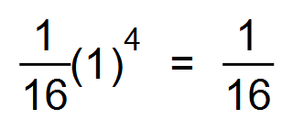 ✓

(c) 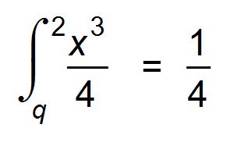 ✓

∴ 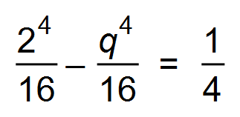 ✓

∴ 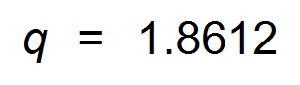 ✓ [7]

9. (a) (i) 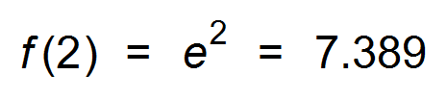 ✓

(ii) 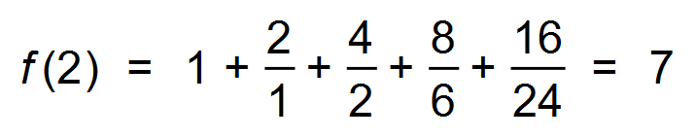 ✓

(b) 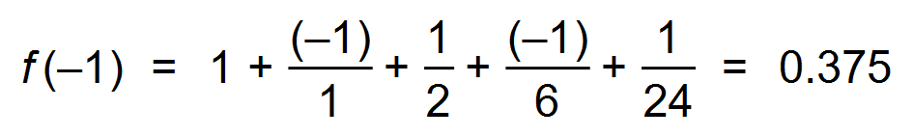 ✓✓

(c) 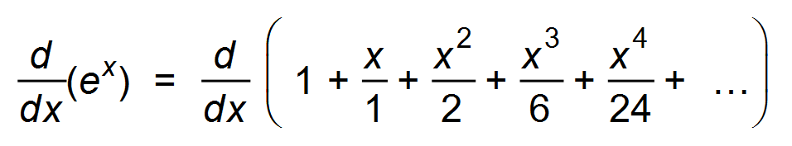 ✓

= 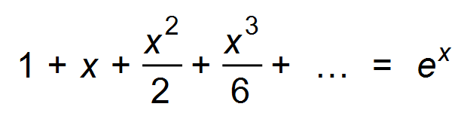 ✓ [6]

10. (a) 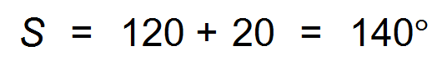 ✓

(b) 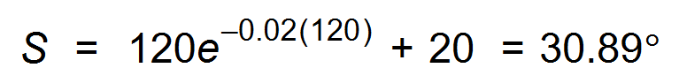 ✓✓

(c) 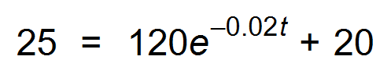 ✓

∴ *t* = 159 seconds ≈ 3 mins ✓✓

(d) 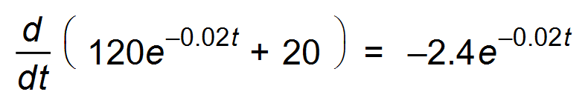 ✓

When *t* = 30, rate = −1.3°/sec ✓ [8]

11. (a) 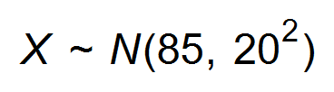

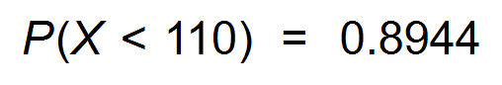 ✓

∴ 89.44% ✓

(b) 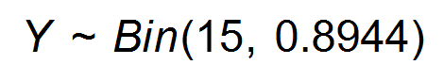

(i) *P*(*Y* = 10) = 0.01292 ✓✓

(ii) 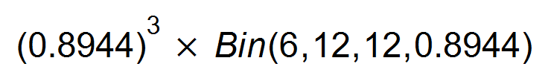 ✓✓

= 0.7154 ✓

(c) $10 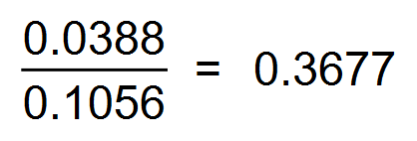 ✓

$20 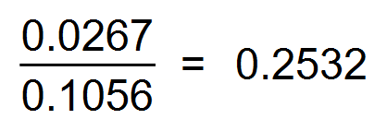 ✓



$30 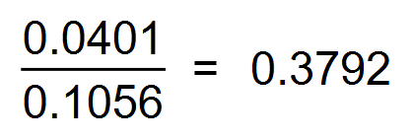 ✓

(d) E(Y) =  ✓

= $20.12 ✓

(e) VAR(Y) =  ✓

= 74.516 ✓

St. Dev. = 8.63 ✓

(f) New Mean = 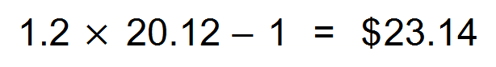 ✓

New St. Dev. = 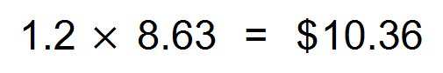 ✓ [17]

12. (a) (i) 17.32 m/min ✓

(ii) 20 m/min ✓

(b) 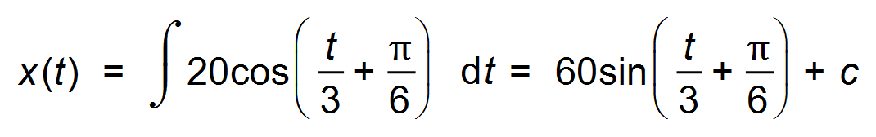 ✓

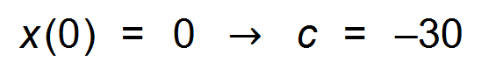 ✓

∴ 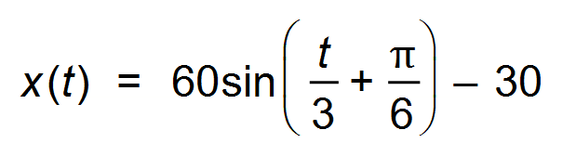 ✓

(c) (i) 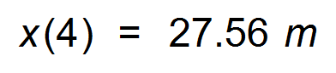 ✓

(ii) 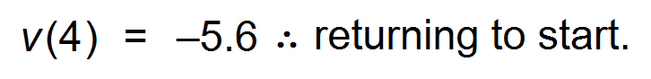 ✓

(d) 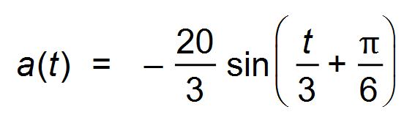 ✓

∴ 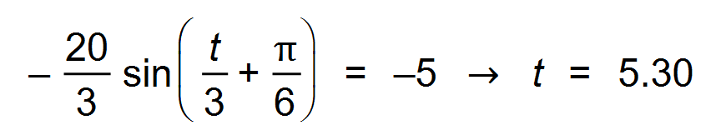 ✓

∴ 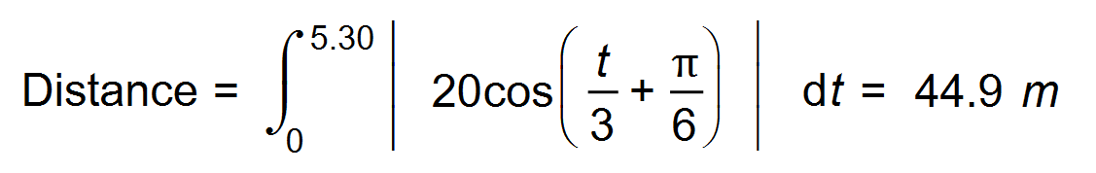 ✓ [10]

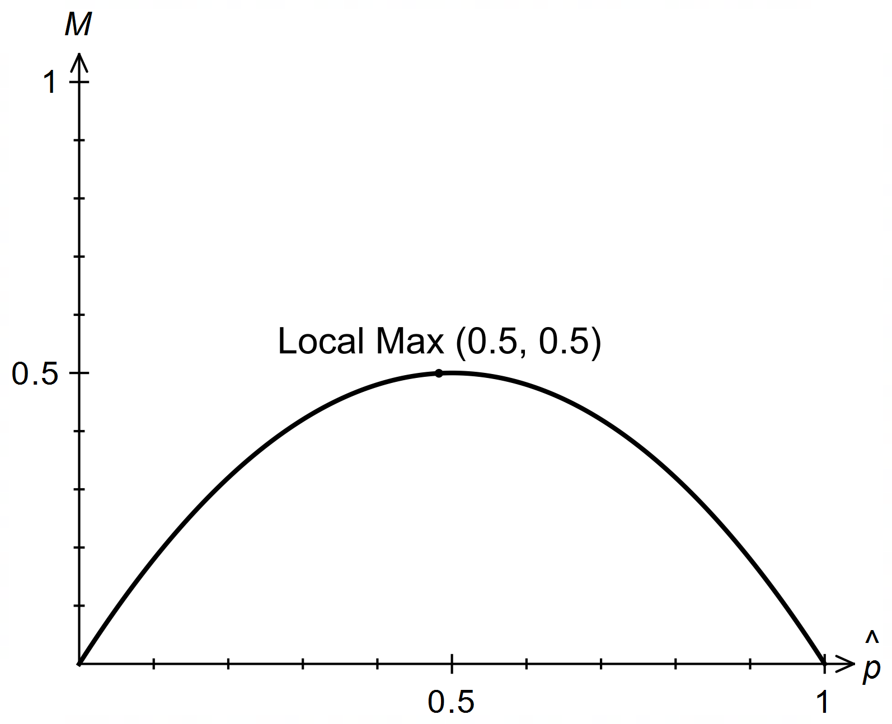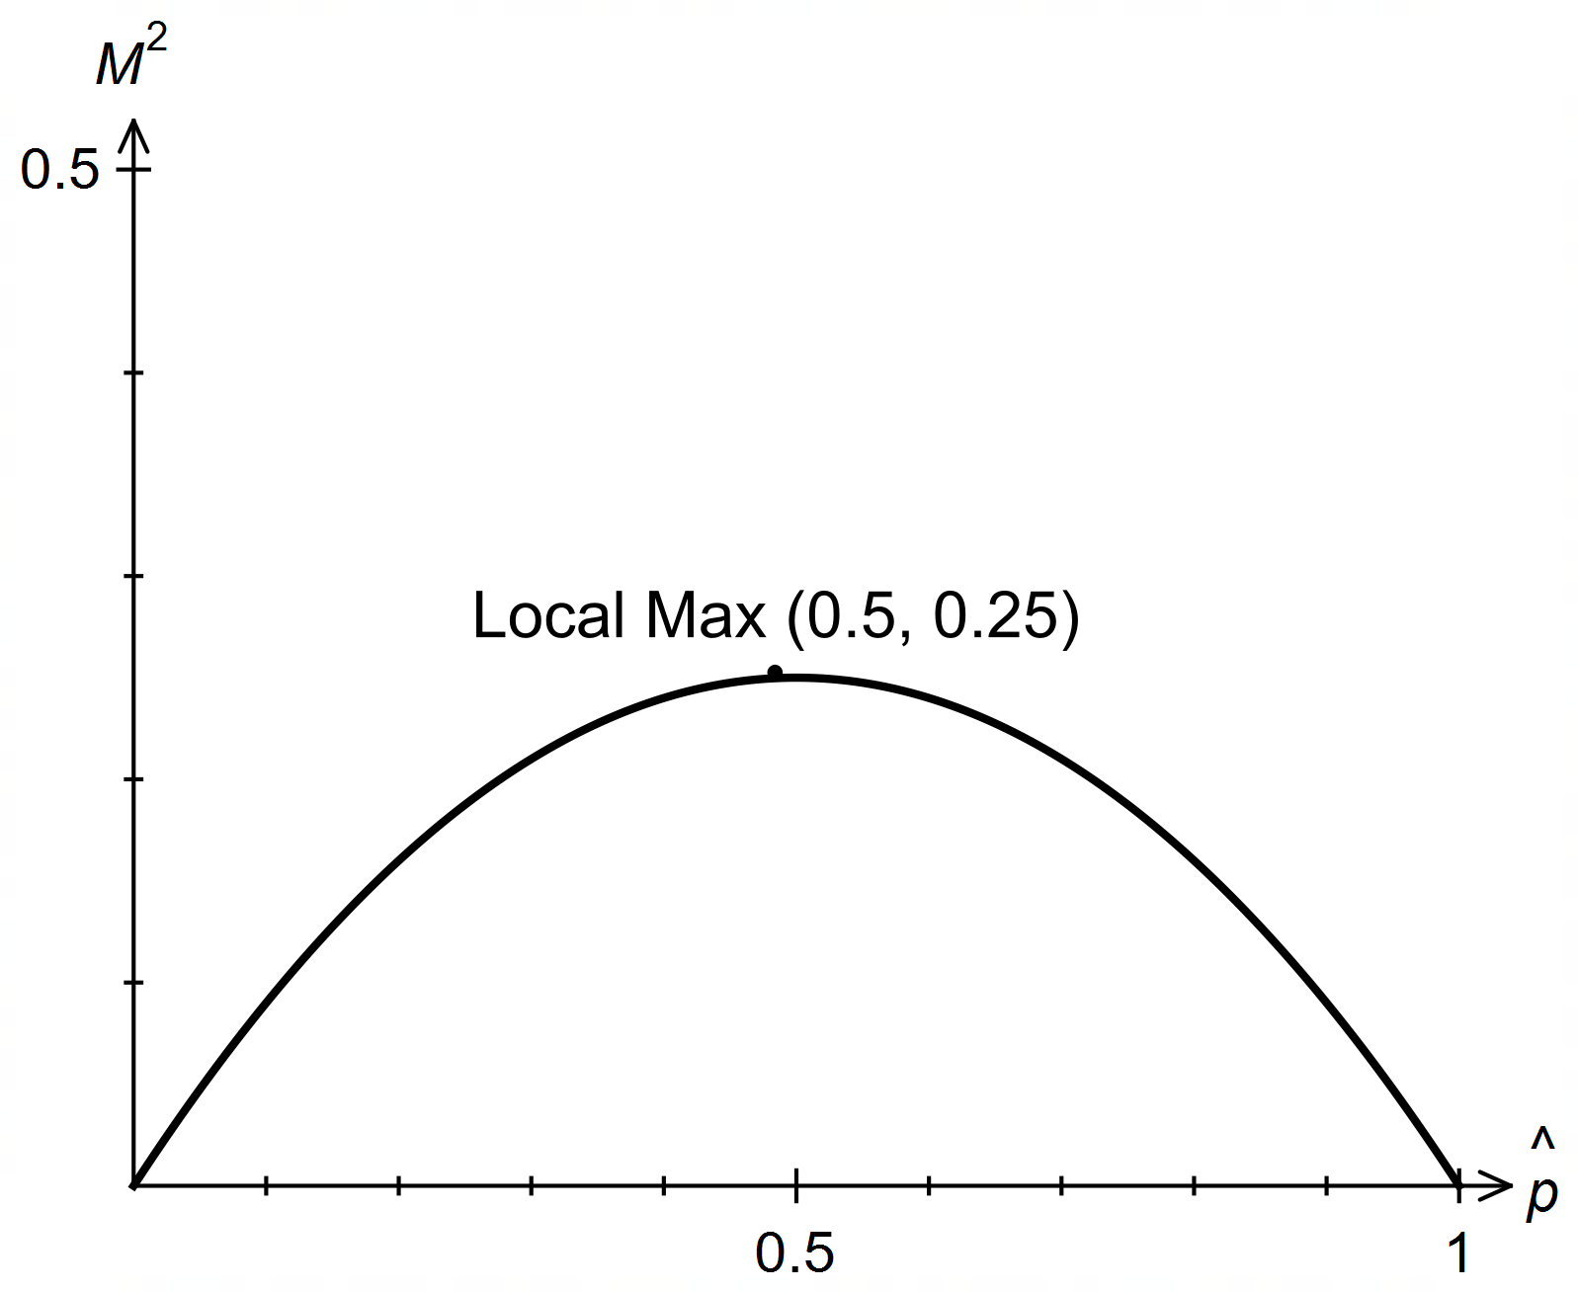13. (a)

**OR**

✓✓

(b) 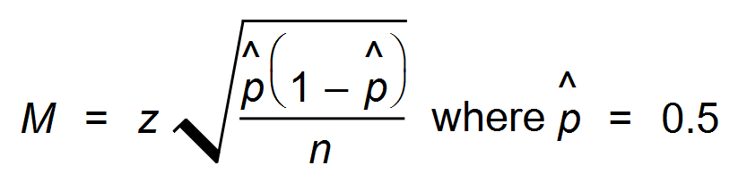

∴ 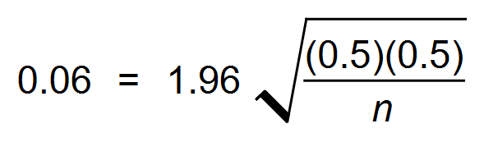 ✓✓

∴ 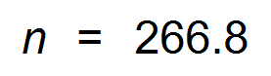 ✓

Hence 267 trainers should be tested ✓

(c) 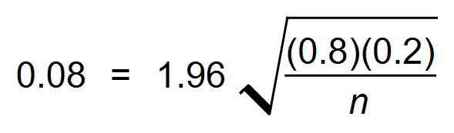 ✓✓

∴ 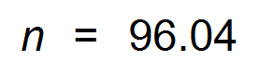 ✓

∴ 96 x 0.8 = 76.8

Hence 76 or 77 trainers would be qualified. ✓ [10]

14. (a) 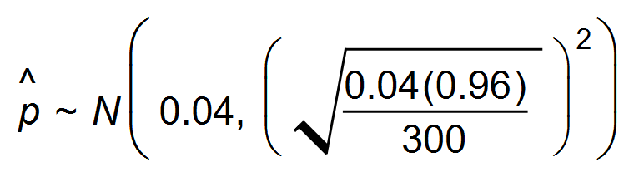 ✓✓

i.e. 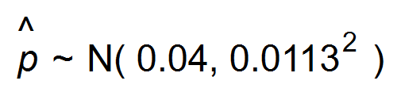 ✓

(b) 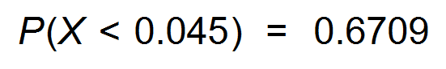 ✓✓

(c) 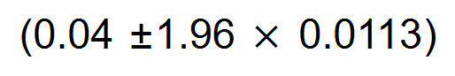 ✓✓

∴ 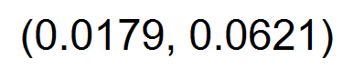 ✓

(d) 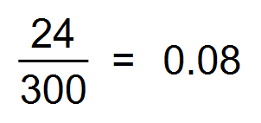 ✓

Since 0.08 is not in the 95% CI ✓

it would be unlikely to happen. ✓

(e) (i) *n* should be larger ✓

Since the formula for standard error has *n* in the denominator,

increasing n will decrease the standard error. ✓

(ii) From the standard normal distn, P (−*k* < *p* < *k*) = 0.98 ✓

*k* = 2.326 ✓ [15]

15. (a) ln 0 doesn’t exist. ✓

(b) 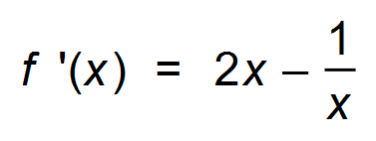 ✓

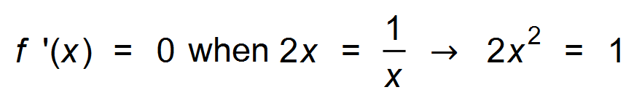 ✓

∴ 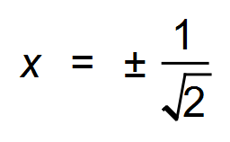 ✓

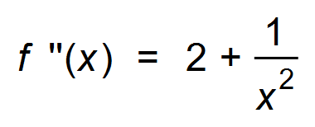 ✓

Since 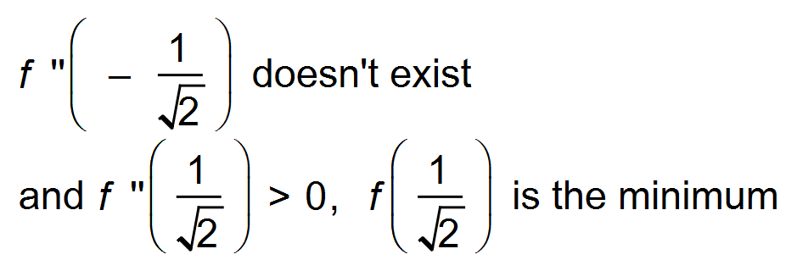

∴ 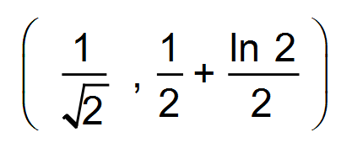 is the minimum point. ✓ [6]

16. (a) (i) *x* = 2 ✓

(ii) *a* = 2 ✓

(iii) We require another set of co−ordinates, as

log*p* 1 = 0 for all *p*. ✓

(b)  ✓

∴ 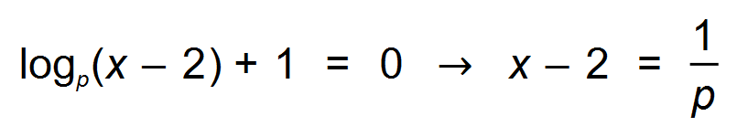 ✓

∴ 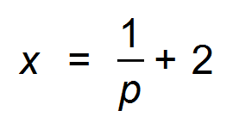 ✓

(c) 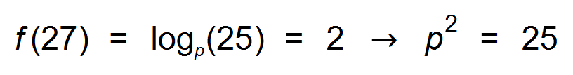 ✓

∴ *p* = 5 ✓ [8]

17. (a) 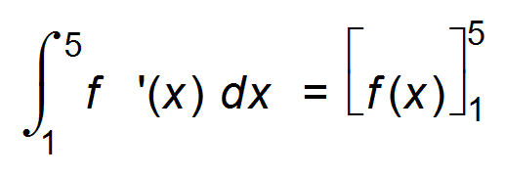 ✓

= 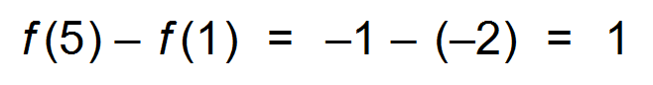 ✓

(b) 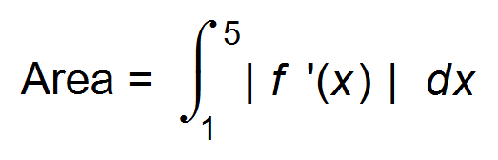 ✓

= 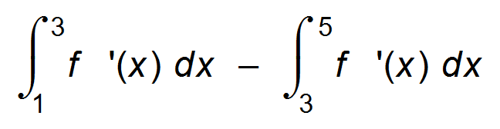 ✓

= 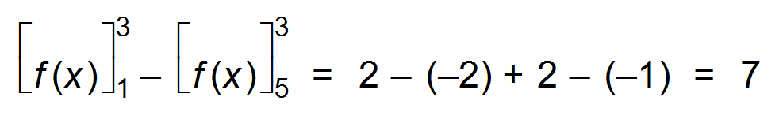 ✓✓ [6]

18. (a) 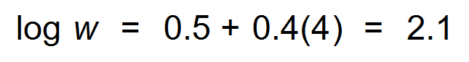 ✓

∴ w = 125.9 *kg* ✓

(b)  ✓✓

(c)  ✓

 ✓

∴ 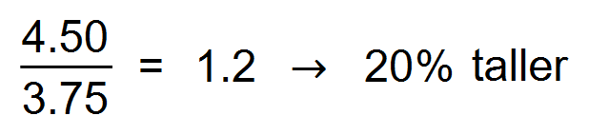 ✓ [7]